# **Raspberry PI Setup**

For the IoT workshop you will need a Raspberry PI 3 running the latest Raspbian. The desktop environment is not required for the labs themselves but it might help you get around easier. NOOBS will install the Desktop version. Please follow the following procedure

## 1 – Getting NOOBS onto an SD card

If you managed to get the 16GB micro SD card move to step 2. If you couldn't get the SD card with NOOBS preloaded on time follow the instructions in this page:

<https://www.raspberrypi.org/learning/noobs-install/windows/>

This basically means downloading NOOBS_v2_4_2.zip from this url

<https://downloads.raspberrypi.org/NOOBS_latest>

Then unzipping it and dump all content to a 16GB SD card that has been formatted as a single FAT32 primary partition

## 2 - Install Raspbian using NOOBS

All you have to do at this stage is inserting it into the Raspberry PI and booting up

<https://www.raspberrypi.org/learning/noobs-install/worksheet/>

You will see a menu like this

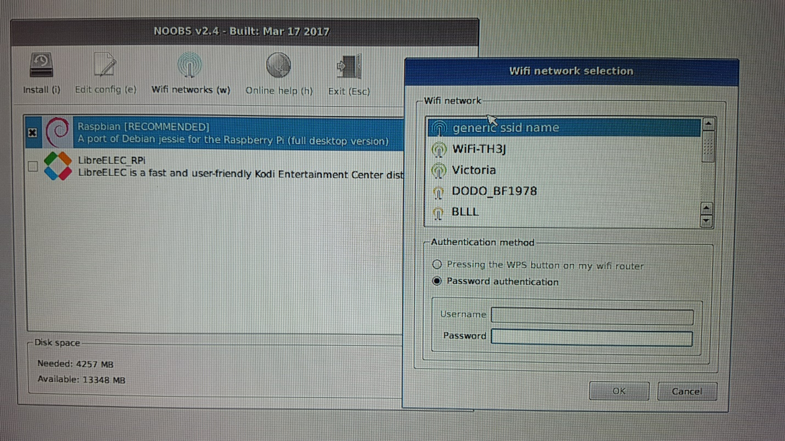

If you provide your WIFI settings it will show you other OS options available. This is nice for future reference, but for the workshop we need Raspbian. Select it and install it

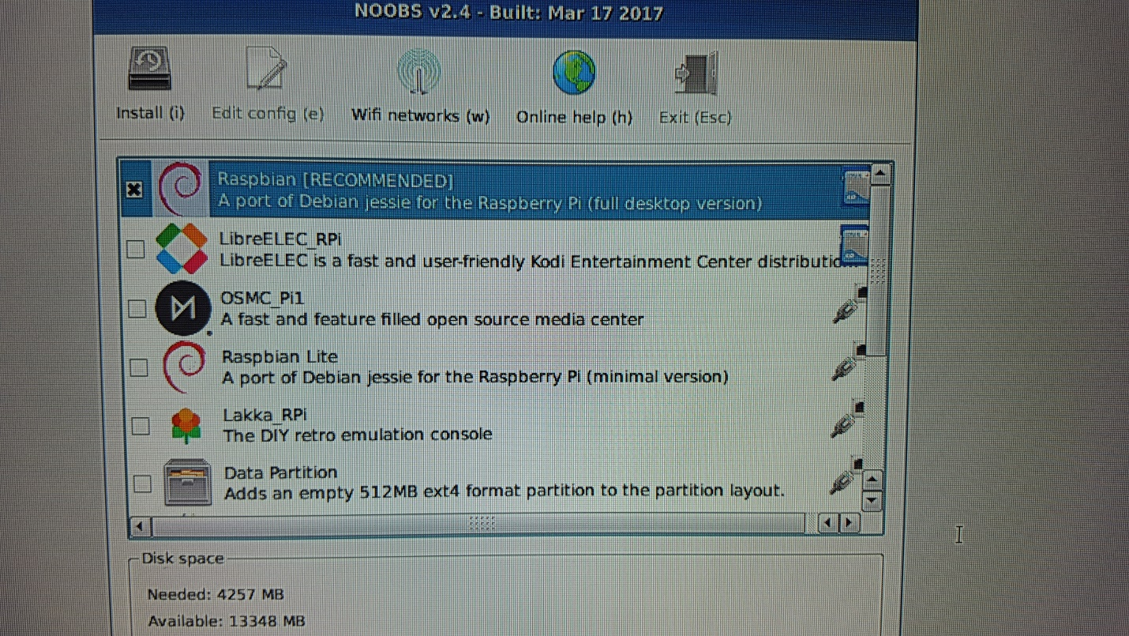

Installation takes about 10 minutes. Once finished it will ask you to reboot at the end

## 3 - Verify you are running Raspbian Stretch

Open a terminal

$ cat /etc/debian_version

9.1

$ cat /etc/os-release

VERSION="9 (stretch)"

## 4 - Enable SSH on the Raspberry PI

Launch Raspberry Pi Configuration from the Preferences menu

* Navigate to the Interfaces tab
* Select Enabled next to SSH
* Click OK

From this point you can log on through Putty and use copy and paste

**IMPORTANT**: consider changing the "pi" user default "password" at this stage

## 5 – apt-get update and verify PIP is installed

It should be installed. If it is not installed then install it

$ sudo apt-get update

$ pip -V

pip 9.0.1

$ sudo apt-get install python-pip

## 6 – Change the keyboard localisation

It comes by default with UK keyboard and you will need to edit some text files so change it to US

Preferences --> Localisation --> Set Keyboard --> US with euro on 5

## 7 - Verify Flask is installed

It should be installed. If it is not installed then install it

$ pip freeze | grep -i flask

Flask==0.10.1

$ sudo pip install flask

## 8 - Verify GPIO is installed

$ pip freeze | grep GPIO

RPi.GPIO==0.6.3

## 9 - Install mosquitto clients

$ sudo apt-get install mosquitto-clients

## 10 - Install paho-mqtt client for Python

$ sudo pip install paho-mqtt

If it fails with an error about "setuptools" you can try the following. Otherwise skip this:

$ sudo pip install -U setuptools

## 11 - Retrieve Python files needed for the labs

Use WGET to download lab scripts from the RPi. You can run this from the Putty session to the RPi. If WGET is not installed you can install it as well

sudo apt-get -y install wget

wget https://raw.githubusercontent.com/cermegno/iot-rpi/master/basic-flask.py

wget https://raw.githubusercontent.com/cermegno/iot-rpi/master/rpi-pub.py

wget https://raw.githubusercontent.com/cermegno/iot-rpi/master/led1.py

wget https://raw.githubusercontent.com/cermegno/iot-rpi/master/led2.py

wget https://raw.githubusercontent.com/cermegno/iot-rpi/master/photoresistor.py

wget https://raw.githubusercontent.com/cermegno/iot-rpi/master/photo-flask.py

wget https://raw.githubusercontent.com/cermegno/iot-rpi/master/photo-pub.py

wget https://raw.githubusercontent.com/cermegno/iot-rpi/master/led-button.py

wget https://raw.githubusercontent.com/cermegno/iot-rpi/master/led-PWM.py

wget https://raw.githubusercontent.com/cermegno/iot-rpi/master/buzzer.py

wget https://raw.githubusercontent.com/cermegno/iot-rpi/master/distance.py

wget https://raw.githubusercontent.com/cermegno/iot-rpi/master/ADC0832.py

## 10 – Setup Networking

**IMPORTANT:** If this is not done prior to coming to the training you won’t be able to do the IoT labs.

The Raspberry PI doesn’t have a monitor, keyboard or mouse built-in. And it is not practical to provide a HDMI monitor and a keyboard for each attendee. Plus the Raspberry PI is unlikely to get a connection to the WiFi in the office. So we have to ensure that you bring your Raspberry PI configured with well-known static IP address as well as predetermined SSID and password to connect to WiFi. The objective is to boot up your Raspberry PI and being able to SSH to its static IP address so that we can perform all the labs that way.

**Option #1**: If you are local to Singapore you might want to configure your Raspberry PI to use the tethering in your phone. You can find out what DHCP IP range your phone uses for connected devices and hard-code a valid IP on your Raspberry PI. In this way if you then connect your laptop to the same Wifi they will be able to see each other and the access the internet

In order to select you mobile hotspot use the little antenna symbol at the top right menu.



Once you have both the RPi and your laptop connected verify connectivity to the Internet and to your laptop:

$ sudo ping www.google.com

$ sudo ping my_laptop_IP

**Option #2**: We will be providing a Wireless Access Point with a well-known SSID, password and static IP information you can use for your Raspberry PI. However this WiFi network won’t provide access to the Internet. It is unlikely that you will need to access the Internet during the labs but if you do you can connect your laptop to the corporate network, download whatever you need to you laptop, reconnect your laptop to the lab network and use WinSCP to transfer the files to the Raspberry PI.

Additionally this network won’t be accessible beforehand so you will have to hard-code the SSID and password as follows. You can use the “nano” editor for this if “vi” gives you hassles:

sudo nano /etc/wpa_supplicant/wpa_supplicant.conf

Go to the bottom of the file and add the following:

network={

ssid="testing"

psk="testingPassword"

}

We will provide the SSID and password in a separate email.

## 11 - Static IP address

Finally in order to configure static IP settings you can edit the “dhcpcd.conf”:

sudo nano /etc/dhcpcd.conf

Then at the very bottom of the file add these the following 4 lines (with your own IP details of course):

interface wlan0

static ip_address=192.168.43.100/24 #####Use your own IP info

static routers=192.168.43.1

static domain_name_servers=192.168.43.1